Peter Julius M. Estacio
Grouped with:
Augusto Gabbriel M. Calilung
Rafael Luis Mari R. Lambo
ENGG 27.01 - M
March 13, 2026

Progress Report 3 for Project 2: Power Method for Eigenvalues and Eigenvectors

As of March 13, 2026, major progress has been made with Augusto Gabbriel M. Calilung and Rafael Luis Mari R. Lambo as groupmates. The program function for calculating the Eigenvalues and Eigenvector of an input matrix has been tested. Additionally, the program is now able to take user input, validate said input, and read a matrix file according to the project specifications. Specifically, the readMatrixFile() function is able to open a filestream based on a user input file name, and dynamically store the matrix values into a 2d vector initialized in the main program. Additionally, a console interface has been developed to accept user input and display the Power Method calculations. Further work then includes allowing the user to opt in or out of displaying the individual traces of the Power Method calculations, along with displaying the final results to the maximum precision available for a double. A screenshot of some of the program results is shown below. This screenshot has been cut for brevity, as the full program output is too long.

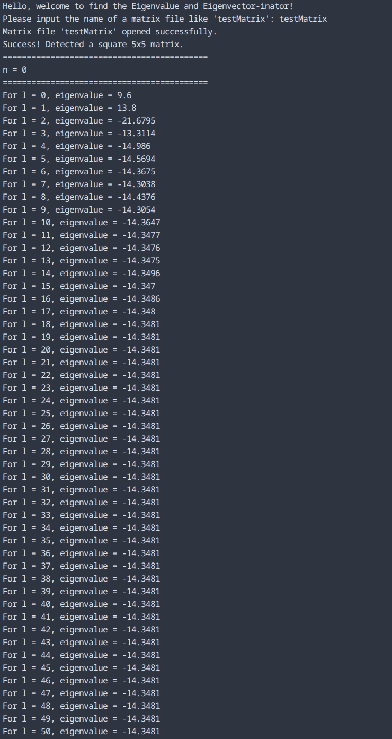
sample screenshots – program executable run and example results
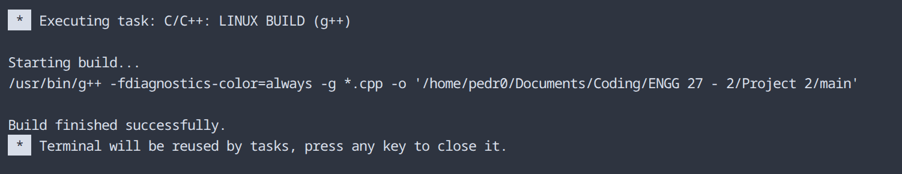
sample screenshot – compilation on Visual Studio Code
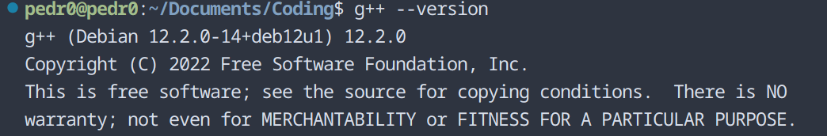
compiler version – g++ (Debian 12.2.0-14+deb12u1) 12.2.0
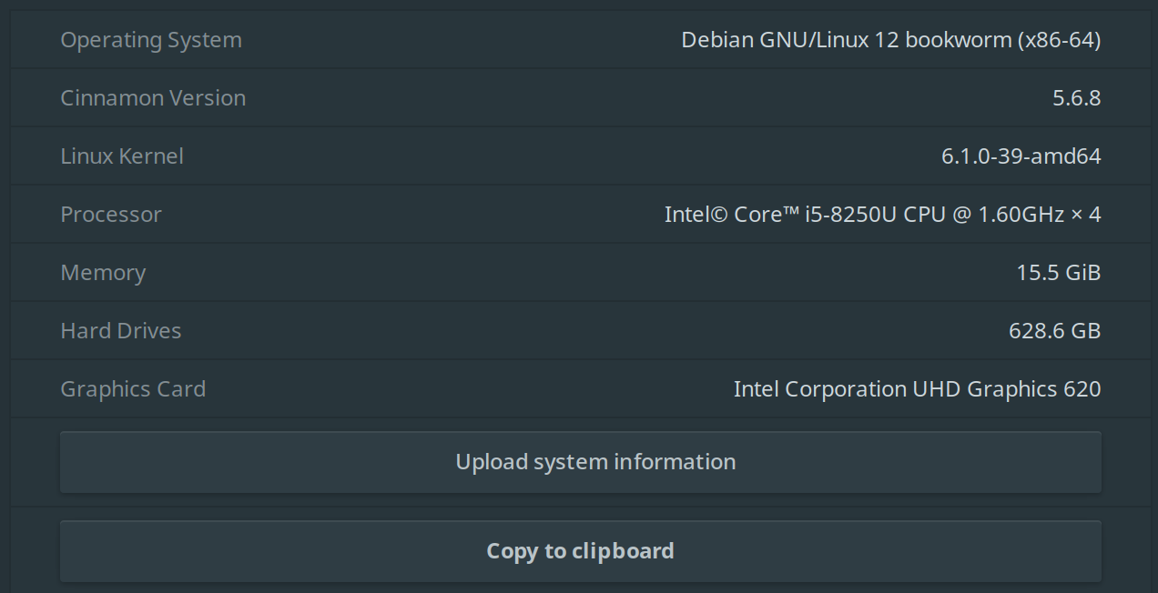
operating system – Debian 12 bookworm, Cinnamon version 5.6.8
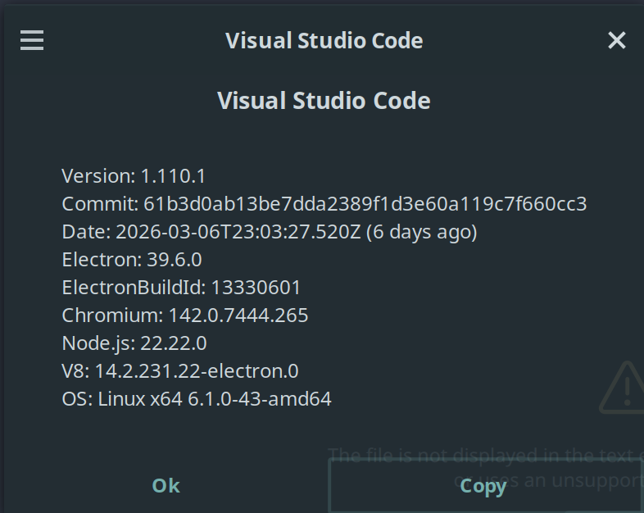
IDE – Visual Studio Code ver 1.110.0

